Impact-blocking device versus self-locking implant arthroereisis for treatment of symptomatic pediatric flatfoot in developing countries.
Original article.
Authors:
- Mahmoud Abouzied; M.D; lecturer of orthopedic surgery, Benha University.1
The corresponding author.
Mail: abouziedmz83@gmail.com
Tel: 01001196707
Benha orthopedic department, 7th floor, Benha university hospitals, Farid Nada Street, Qalubyia, Egypt.
2-Ahmed Ramy; M.D; lecturer of orthopedic surgery, Helwan University.
No of pages: 11
No of photographs: 12
Abstract word count: 197
- Text word count: 3761
Introduction and discussion word count: 1350
We would like to express our deep thanks to the patients and Benha orthopedic department.
No financial nor material support was received for this study.
No conflicts of interest.
The manuscript has been read and approved by all the authors.

Impact-blocking device versus self-locking implant arthroereisis for treatment of symptomatic pediatric flatfoot in developing countries.

Background:
Pediatric flexible flatfoot is a common presenting condition. Surgical treatment is only indicated for symptomatic cases not responding to conservative measures. Surgical options include soft tissue enforcement, arthroereisis, osteotomies, and arthrodesis. Arthroereisis carries a lot of controversies regarding age limit, mechanism of action, implants, durability, complications and the exact time for removal. In this study we design a randomized comparative study to evaluate the differences between impact blocking device and self-locking implant used in subtalar arthroereisis.
Patients and methods:
Seventy feet were included in the study in forty five patients. Symptomatic flexible flatfeet not responding to the conservative treatment in patients whom ages ranged from 10 to 14 years were included in the study. Patients were randomly divided in 2 groups for each procedure. Preoperative and 3 years postoperative clinical, radiological and functional assessment was done with evaluation of complications.
Results:
Three patients who did not complete 3 years follow up were excluded in which 31 feet were operated for impact blocking device (calcaneal stop procedure) and 34 feet were operated for self-locking implant. The overall results of the study showed statistically significant improvement between pre-operative and post-operative hind foot valgus angle, Meary's angle, calcaneal pitch angle, talar head coverage angle and AOFAS score for both groups. No significant differences between the two groups regarding clinical, radiographic or functional outcomes.
Key-words:
Flexible flatfoot; subtalar arthroereisis; impact-blocking device; self-locking implants
Introduction:
Flexible flatfoot is the most common pediatric condition. ^{{1}} It is physiological till ten years and characterized by loss of medial longitudinal arch with valgus heel deformity. ^{{2}} Although the wide prevalence of flexible flatfeet; the symptomatic children represent a small proportion of cases. ^{{3}} the first choice in treatment of symptomatic flatfeet is conservative treatment including activity modifications, stretching, medial arch support. ^{{4}} Surgical treatment is only indicated for symptomatic cases not responding to conservative measures. Surgical options include soft tissue enforcement, arthroereisis, osteotomies, and arthrodesis. ^{{5}} several authors have reported on the validity, efficacy, safety and minimal invasiveness of arthroereisis procedures. ^{{6}} Arthroereisis aims at re-establishing the medial foot arch and limiting the subtalar joint motion. ^{{7}} Chambers in 1946 described impaction of wedge shaped bone block into the anterior part of calcaneal posterior facet to limit the excessive anterior talar displacement to correct the flatfoot deformity. ^{{8}} Pursuing the same aim, Haraldsson described a wedge graft in the sinus tarsi and firstly termed it as "arthrohisis". ^{{9}} Lelievre in 1970 introduced "arthroereisis" term to describe a bone fraft in the sinus tarsi fixed with staple. ^{{10}} Subotnick in 1974 described a synthetic implant to be placed in the sinus tarsi. ^{{11}} Later on, a lot of emerging implants were introduced in the market which are widely different in shape, material and mechanism of action. ^{{7}}
Vogler ^{{12}} in 1987 classified the mechanism of action of arthroereisis into three main types: (figure 1)
1- Axis altering prosthesis: vertically placed implant in the sinus tarsi just anterior to the posterior facet with its head come in contact with the lateral talar process to modify the subtalar joint axis and limit the internal rotation of the calcaneus.
2-impact blocking devices: the same as the former implant apart from it is placed slightly more anterior to impinge with the lateral talar process limits its anterior gliding.
3-self-locking implant: inserted with in the long axis of sinus tarsi, supporting the talar neck and prevent the lateral talar process to be in contact with sinus tarsi floor. It limits talar adduction and planterflexion.
Apart from the mechanical effect of arthroereisis, a hypothetical proprioceptive action was introduced related to the mechanoreptors found within and around the sinus tarsi. This hypothesis has never been proved. ^{{13}}
Lack of understanding the superiority between different arthroereisis implants and the concerns about the complications of each device together with financial concerns push the authors to compare between the impact blocking devices and self-locking implants regarding clinical outcome, radiological improvement, Functional scores and complications.
Patients and methods:
Seventy feet were included in the study in forty five patients. Symptomatic flexible flatfeet not responding to the conservative treatment in patients whom ages ranged from 10 to 14 years were included in the study. Symptomatic patients were defined as patients suffered from frequent episodes of calf muscle strain, sub-talar head medial side foot pain, lateral side sub-fibular impingement pain or foot wear intolerance. The flexibility of deformity depends on heel rise test. Failure of conservative treatment was defined as persistent pain and/or foot wear intolerance after 6 months of wearing hard flatfeet insole together with Achilles stretching exercises.
Excluded patients were whom with rigid flatfeet, asymptomatic flexible flatfeet, patients with neurological disorders, history of pervious foot surgery, joint hyper laxity, and patients under ten years or over fourteen years.
Forty five patients with symptomatic flexible flatfeet with failed conservative treatment for six months sought medical advice at our institute from February 2016 to December 2018. Patients were divided in to single and even numbers with the single numbers were managed by impact blocking device (calcaneal stop screw) (group 1) and the even numbers were treated with self-locking implant (arthroereisis screw) (group 2).
Preoperative assessment was done clinically to exclude equinus deformity. Equinus deformity was defined as less than 10 degrees ankle dorsiflexion. Patients with equinus deformity were examined with silverskoild test to assess the source of the deformity either from the gastrocnemius tightness or the Achilles tightness. The degree of hindfoot valgus deformity was assessed clinically by goniometer.
Preoperative radiological assessment was done lateral standing plain X-ray view of the ankle and foot to determine the Meary's angle and the calcaneal pitch angle which used as indicators for the degree of flatfeet deformity and by standing anteroposterior plain X-ray foot view to determine the talar head coverage angle which used as indicator for forefoot abduction.
Preoperative functional assessment was done using American foot and ankle society (AOFAS) score
The institute ethical committee provided ethical clearance for the study and all the primary caregivers of the children provided informed consent.
Operative details:
The patients were operated under general anesthesia in supine position with thigh tourniquet. According to Silverskoild test, Achilles tendon lengthening or gastrocnemius recession was done when indicated with knee flexion position. Limited 2-4 cm incision was done 2 cm distal and anterior to the tip of the lateral malleolus. Debridement of sinus tarsi was done.
For impact blocking device (calcaneal stop procedure); with subtalar inversion, a 3.2 drill hole was done vertically in the calcaneus just anterior to the posterior facet. A 4.5 mm cortical stainless self-taping screw (8mm head) with a lenghth of 30mm to 35mm (Synthes LCP, Bettlach, Swizerland) was inserted allowing its prominent head to impinge against the lateral talar process. The extent of screw head prominence was determined by its ability to minimize subtalar eversion to approximately 2-4 degrees. One or two screw washers were used to support the screw head prominence to the desired proper extent.
For self-locking implant; blunt probe was used to direct the trial dilators in the sinus tarsi. Prober sized trail dilator limit the subtalar eversion to approximately 2-4 degrees, had a good purchase and the tail end of the implant 1.5 cm beyond the lateral calcaneal wall checked under fluoroscopy. Proper size of HyProCure TM subtalar implant system was inserted.
Wound closure with compression bandage was used. Weight bearing was encouraged in the 2nd postoperative day as tolerated except for patients with Achilles lengthening or gastrocnemius recession in which it was delayed for 6 weeks. Proprioception exercises were done within the first week or within the 7th week in cases of Achilles lengthening or gastrocnemius recession. Jumping was prohibited in the first 6 months postoperatively.
Final postoperative assessment was done clinically by measuring hindfoot angle, AOFAS score. The results of AOFAS score were divided into subgroups as results over or equal 90 were considered excellent, between (80-89) were considered good, between (70-79) were considered fair and less than 70 were considered poor. Final postoperative radiological assessment was done by measuring the Meary's angle, the calcaneal pitch angle and talar head coverage angle.
Results:
The final number of included patients was 42 patients after exclusion of 3 children who did not complete 3 years follow up. 31 feet were operated for impact blocking device (calcaneal stop procedure) and 34 feet were operated for self-locking implant. The mean patient age was 11.9 (range 10 to 14) years for the impact blocking procedure and 12 (range 10.5 to 13.7) years for the self-locking implant. The mean duration follow up was 42 (range 38 to 46) months. 16 feet underwent adjuvant procedure in the impact blocking group in the form of gastrocnemius recession for 7 feet and Achilles lengthening for 9 feet. 19 feet of the self-locking implant group underwent adjuvant procedure in the form of gastrocnemius recession for 9 feet and Achilles lengthening for 10 feet.
Table 1 lists the baseline and final follow up scores of clinical, radiographic and functional parameters for both groups. The overall results of the study showed statistically significant improvement between pre-operative and post-operative clinical, radiographic and functional measurements for both groups. No significant differences between the two groups regarding clinical, radiographic or functional outcomes. Regarding postoperative results of AOFAS score (table 2); in group1; 18 feet were excellent, 12 feet were good and one foot was poor and in group 2; 16 feet were excellent, 16 feet were good and 2 feet were poor. (Figure: 2, 3 and 4)

Table1: clinical, radiographic and functional results for both groups.
Talar head coverage angle (±SD)  (figure 2) | Calcaneal pitch angle (±SD)  (figure 2) | Meary's angle (±SD)  (figure 2) | AOFAS score (± SD) | Hind foot valgus angle deformity (±SD) | Group
16.09 (3.1) | 10.67 (2.32) | 18.38 (1.6) | 61.93 (8.74) | 16.67 (5.12) | Preoperative group 1
5.77 (1.02) | 19.7 (4.12) | 4.41 (0.9) | 89.38 (6.46) | 4.25 (3.6) | Final Postoperative group 1 ( 3 years)
17.47 (2.34) | 9.91 (1.88) | 18.64 (2.11) | 57.82 (7.58) | 16.6 (7.23) | Preoperative group 2
6.76 (1.62) | 18.88 (3.73) | 6.14 (1.02) | 87.88 (8.43) | 5.47 (4.11) | Final Postoperative group 2 ( 3 years)

Table 2: postoperative AOFAS score results.
Poor | Fair | Good | Excellent | Group
1 (3.22%) | 0 | 12 (38.7%) | 18 (58.06%) | group 1
2 (5.88%) | 0 | 16 (47.05%) | 16 (47.05%) | group 2

The reported complications (table 3) were sinus tarsi pain, peroneal muscle spasm, implant extrusion (Figure 5) and superficial wound infection. Seven feet complained of sinus tarsi pain, four feet were in group 1 and three feet in group 2. The symptoms were mild in five cases, moderate in two cases and related to the activity. The onset of pain was at a mean of 8 months postoperatively. Initial management in the form of non-steroidal anti-inflammatory drugs with activity modifications. Three patients were in need for screw removal after completion of 3 years follow up due to persistent pain not responding to medications and activity modifications in which two of the former three patients was in group 1 and the other was related to group 2.
Three patients were complicated with peroneal muscle spasm. Two were related to group 2 and the other were related to group 1. It was disappointing complication as pain and deformity were worse postoperatively in which the pain increased and the deformity became rigid due to the superadded peroneal spasm even with presence of the implant. The mean onset of symptoms in these three cases was within 14 months postoperatively. Two cases, one of each group responded well with peroneal nerve block with subtalar manipulation, sinus tarsi steroid injection and below knee casting for 6 weeks. The other case of group 2 was resistant to the former management and responded to screw removal after completion of 3 years follow up postoperatively.
Two cases related to group 2 were complicated with implant extrusion. (Figure: 5) Implants were extruded 4 and 7 months postoperatively. We found that the extruded implants were of large sized implants (12mm). They were treated with screw removal and re-implantation of a new implants.
Implant removal was indicated in group 1 in two cases due to persistent sinus tarsi pain and in four cases related to group 2; one due to persistent sinus tarsi pain, one for resistant peroneal muscle spasm and the last two cases due to implant extrusion.
Thirteen patients in group 1 and twenty one patients in group 2 were recreational athletes. We compare their participation in sports in the last 6 months before surgery and at 3 years postoperatively. The mean preoperative participation was 1.5 hours per week and became 6.2 hours per week at the final follow up which was significant improvement in both groups but there was no significant difference between the two groups.
Table 3: postoperative complication.
Implant removal | Superficial wound infection | Implant extrusion | Peroneal muscle spasm | Sinus tarsi pain | Group
2 (6.45%) | 1 (3.22%) | 0 | 1 (3.22%) | 4 (12.9%) | group 1
4 (11.76%)  ( 2 re-implanted) | 0 | 2 (5.88%) | 2 (5.88%) | 3 (8.82%) | group 2

Discussion:
Subtalar arthroereisis is still debated procedure for treating flatfeet regarding indications, age limits, type of implant, complication rate, need of removal and long term follow up. This debate is mainly due to lack of high quality studies which can answer the former inquiries. Surgeons depends on personal experience in performing arthroereisis rather than structured scientific work. In many case series arthroereisis was described as minimal, effective method for treatment of flexible flatfeet but the results was heterogeneous. ^{{7}}
Subtalar arthroereisis till now was assigned as grade C recommendation (conflicting and poor quality evidence) therefore no recommendation for or against the procedure. ^{{14}}
In the current study we investigated the comparison between impact blocking and self-locking implants used for subtalar arthroereisis in treatment of symptomatic flexible flatfeet. The comparison included the effect on the degree of flatfeet deformity by Meary's angle measurement, calcaneal pitch angle, hind foot valgus deformity through assessment of hind foot angle, forefoot abduction by measurement of talar head coverage angle, clinical assessment by AOFAS score and documentation of the resultant complications for both groups.
Regarding the investigated parameters, significant improvement was achieved in the study groups but the difference between the two groups was insignificant. The two groups had significant improvement in flatfoot deformity correction through significant correction of Meary's angle and calcaneal pitch angle. Significant improvement in forefoot abduction through improvement of talar head coverage angle. Significant functional improvement assessed the pain, function and alignment by the AOFAS score was noticed for both groups. No significant difference between the two groups in its corrective power either for flatfeet deformity, forefoot abduction, pain or function.
Chong et al, in 2015 compare between arthroereisis and lateral column lengthening (Evans osteotomy or calcaneocuboid fusion with gastrocnemius recession or peroneal tendon transfer) in 24 feet through prospective nonrandomized comparative study. Satisfactory results were obtained for both procedures including radiographic parameters, clinical scores and pedobarometry with similar complications and comparable reoperation rates. They concluded that arthroereisis can be a reliable procedure. ^{{15}}
Based on different cohort non comparative studies, authors reported that arthroereisis either with impact blocking implants or self-locking device is an optimal minimal invasive procedure for treatment of flexible flatfoot in children. ^{{16, 17}}
Pavone et al in 2018 studied the outcomes of the impact blocking implants (calcaneal stop procedure) for treatment of juvenile flexible flatfeet in young athletes and concluded that this technique improve radiographic clinical parameters with minimal invasiveness together with early improvement and long term maintenance of sports activity level. We documented the improvement of activity level of recreation athletes who participated in the study. The mean preoperative participation was 1.5 hours per week and became 6.2 hours per week at the final follow up which was significant improvement but with insignificant difference between both groups. ^{{18}}
Sakti et al in 2017 studied the effectiveness of impact blocking implants in treatment of symptomatic plano-valgus deformity and concluded that it was a simple, reliable, effective and minimal invasive technique for treatment of flexible pediatric flatfoot but there was lack in gait improvement and they referred it to the foot modeling technique rather than the operating technique. ^{{19}}
Ozan et al in 2015 studied the effect of self-locking implant for treatment of symptomatic flexible flatfeet in adults and founded it as feasible, minimal invasive technique which can be considered a basic procedure for treatment of flexible flatfeet. ^{{20}}
In our study, no significant difference at the final follow up between patients were in need for additional equinus correction and whom were with normal range of motion. It was no correlation between radiographic parameters improvement and clinical outcome regarding AOFAS score as less improved radiographic parameters can demonstrate excellent AOFAS score outcome and this was related mainly to pain improvement.
The most common complication reported in our study was sinus tarsi pain. It was in 4 feet in group 1 (12.9%) and 3 feet in group 2 (8.82%). This pain was in need for implant removal in 3 feet; two were related to group 1 and the other was related to group 2. Other investigators concluded also that sinus tarsi pain undoubtedly the most common complication. ^{{21, 22}}
The most irritating complication was peroneal spasm which occurred in one patient (3.22%) belong to group 1 and two patients (5.88%) related to group 2.
Regarding implant removal, two feet related to group 1 (6.45%) were in need for screw removal due to persistent sinus tarsi pain. Four feet (11.76%) were indicated for implant removal; half of them due to implant dislodgment, one feet due to persistent sinus tarsi pain and the last one for peroneal spasm not responding to peroneal nerve block, steroid injection and below knee casting. In our study; we did not remove the implants routinely. No precise data in the previous studies were available about the minimum time required to maintain long-lasting correction. Some Studies have focused on risk factors of implant removal and concluded that over-sized implants and radiographic under correction were the main risk factors. Removal in cases other than implant extrusion was done one year after implantation. Recurrence of the deformity was not observed during the follow up period after implant removal. Cases with implant extrusion; implants were re-implanted in which the extrusion occurred less than one year postoperatively (4 and 7 months postoperatively). ^{{23, 24}}
Superficial wound infection was reported in one case related to group 1, it was minimal complication and was not related to the procedure technique. Other investigators documented other complications which not reported in our study as screw loosening and screw breakage in implant blocking procedures.
In conclusion, although both procedures can significantly improve clinical, radiological and functional parameters of symptomatic flexible flatfeet but, the difference between both techniques is insignificant. Complications were represented in sinus tarsi pain which was the commonest. It represented 12.9% in group1 and 8.8% in group 2. Proneal muscle spasm which was the most irritating. 3.2% and 5.8% of cases were complicated by peroneal muscle spasm in group 1 and 2 respectively. Implant expulsion which was related to self- locking implants in 5.8% of cases.
References:
1- Yontar N S, Ogut T, Mehmet T, Guven M F, Botanlioglu H, Kaynak G, Can A: Surgical treatment results for flexible flatfoot in adolescents. Acta Orthop Traumatol Turc 2016; 50: 655-659.
2- Pourghasem M, Kamali N, Farsi M, Soltanpour N. prevalence of flatfoot among school students and its relationship with BMI. Acta Orthop Traumatol Turc 2016; 50: 554-557.
3- Dare DM, Dodwell ER. Pediatric flatfoot: cause, epidemiology, assessment, and treatment. Curr Opin Pediatr 2014; 26: 93-100.
4- Evans AM. The flat-footed child – to treat or not to treat: what is the clinician to do? JAm Podiatr Med Assoc 2008; 98:386-393.

5- Kwon JY, Myerson MS. Management of the flexible flatfoot in the child: a focus on the use of osteotomies for correction. Foot Ankle Clin 2010; 15(2): 309-22.

6- Costa FP, Costa G, Carvalho MS, Moura AM, Pinto R, Torres J. Long-Term Outcomes of the Calcaneo-Stop Procedure in the Treatment of Flexible Flatfoot in Children: A Retrospective Study. Acta Med Port 2017 Jul-Aug; 30(7-8):541-545.
7- Allessio B, Francois L, Francesco S. the role of arthroereisis of the subtalar joint for flatfoot in children and adults. EFFORT Open Rev. 2017; 2: 438-4460
8- Chambers EF. An operation for the correction of flexible flat feet of adolescents.West J Surg Obstet Gynecol 1946; 54:77-86.

9- Haraldsson S. Operative treatment of pes planovalgus staticus juvinilis. Acta Orthop Scand 1962; 32:492-498.

10- L elièvre J. Current concepts and correction in the valgus foot. Clin Orthop Relat Res 1970; 70:43-55.

11- Subotnick SI. The subtalar joint lateral extra-articular arthroereisis: a preliminary report. J Am Podiatry Assoc 1974; 64:701-711.

12- Vogler H. ‘Subtalar joint blocking operations for pathological pronation syndromes’.In: McGlamery ED, ed. Comprehensive textbook of foot surgery. Baltimore: Williams Wilkins, 1987:466-482.

13- Usuelli FG, Montrasio UA. The calcaneo-stop procedure. Foot Ankle Clin
2012; 17:183-194.

14- Schon LC. Subtalar arthroereisis: a new exploration of an old concept. Foot Ankle Clin 2007; 12:329-339, vii.

15- Chong DY, Macwilliams BA, Hennessey TA, Teske N, Stevens PM.
Prospective comparison of subtalar arthroereisis with lateral column lengthening for painful flatfeet. J Pediatr Orthop B 2015; 24:345-353.

16- Kellermann P, Roth S, Gion K, Boda K, Tóth K. Calcaneo-stop procedure for paediatric flexible flatfoot. Arch Orthop Trauma Surg 2011; 131:1363-1367.

17- De Pellegrin M, Moharamzadeh D, Strobl WM, et al. Subtalar extra-articular screw arthroereisis (SESA) for the treatment of flexible flatfoot in children. J Child Orthop
2014; 8:479-487.

18- Pavone V, Vescio A, Di Silvestri CA, Andreacchio A, Sessa G, Testa G. Outcomes of the calcaneo-stop procedure for the treatment of juvenile flatfoot in young athletes. J Child Orthop. 2018; 12(6):582-589.

19- Das SP, Das PB, S. G, Sahu MC. Effectiveness of surgically treated symptomatic planovalgus deformity by the calcaneo stop procedure according to radiological, functional and gait parameters. J Taibah Univ Med Sc 2017; 12(2):102e109.

20- Ozan, Fırat & Doğar, Fatih & Gençer, Kürşat & Koyuncu, Semmi & Vatansever, Fatih & Duygulu, Fuat & Altay, Taşkın. Symptomatic flexible flatfoot in adults: Subtalar arthroereisis. Therapeutics and clinical risk management. 11. 1597-602. 10.2147/TCRM.S90649, 2015.

21- Metcalfe SA, Bowling FL, Reeves ND. Subtalar joint arthroereisis in the management of pediatric flexible flatfoot: A critical review of the literature. Foot Ankle Int 2011; 32(12):1127-39. Review.

22- Shah NS, Needleman RL, Bokhari O, Buzas D. 2013 Subtalar arthroereisis survey: the current practice patterns of members of the AOFAS. Foot Ankle Spec 2015; 8:180-185.

23- Cook EA, Cook JJ, Basile P. Identifying risk factors in subtalar arthroereisis
explantation: a propensity-matched analysis. J Foot Ankle Surg 2011; 50:395-401.

24- Saxena A, Via AG, Maffulli N, Chiu H. Subtalar Arthroereisis Implant Removal in
Adults: A Prospective Study of 100 Patients. J Foot Ankle Surg 2016; 55:500-503.

Figure 1: types of arthroereisis implants.
The three types of subtalar arthroereisis; a: axis altering, b: impact blocking and c: self-locking. The position of implant in the joint is illustrated in red and the main force generated between the talus and calcaneus is illustrated in violet, blue and brown arrows. ⁷

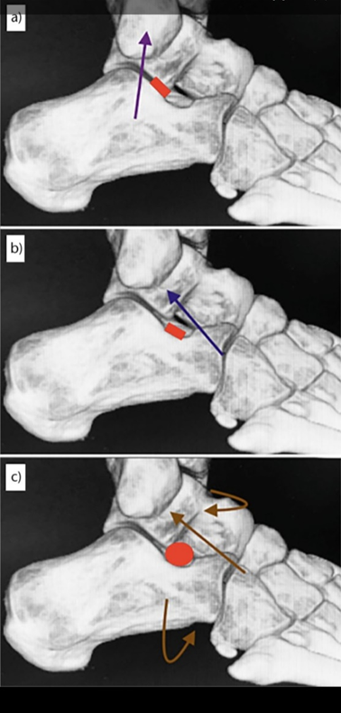

Figure 2: radiographic parameters.
1: lateral standing X-ray view ankle showing Meary's angle in black lines and calcaneal pitch angle in white lines.
11
2: antero-posterior (A-P) standing foot X-ray showing talar head coverage angle in yellow arc, c-d line represents proximal articular surface of the navicular bone, a-b line represents the articular line of talar head, A represents a perpendicular line on a-b, and B represents a perpendicular line on c-d.
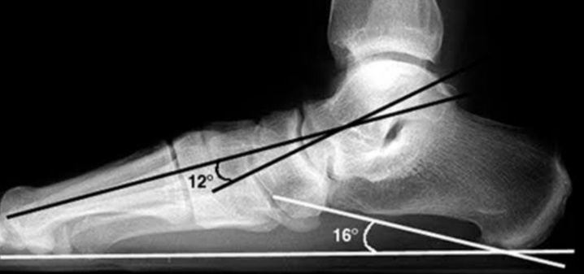
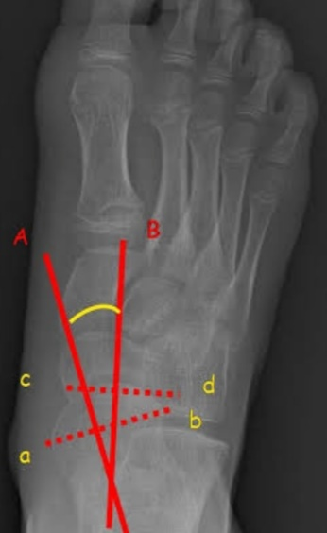
2

Figure 3: impact blocking arthroereisis implant.
A: preoperative clinical photo showing the valgus heel deformity, B: preoperative lateral standing X-ray ankle and foot, C; postoperative clinical photo showing the corrected hind foot valgus deformity, D: postoperative lateral standing X-ray ankle and foot, E: preoperative standing X-ray foot showing talar head uncoverage and F: postoperative standing X-ray foot showing the corrected talar head conerage.
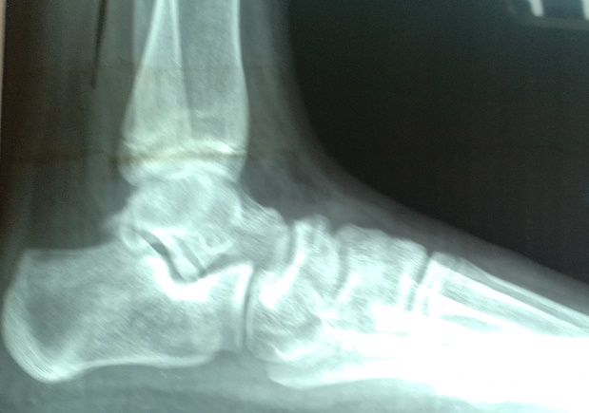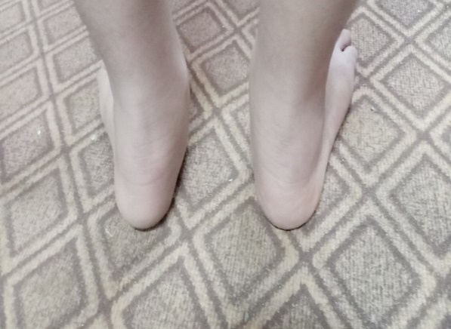
B
Your text here
A text here
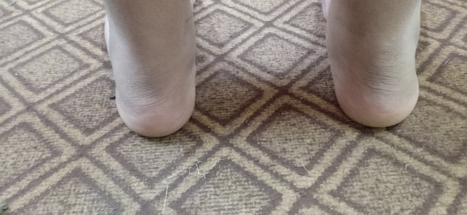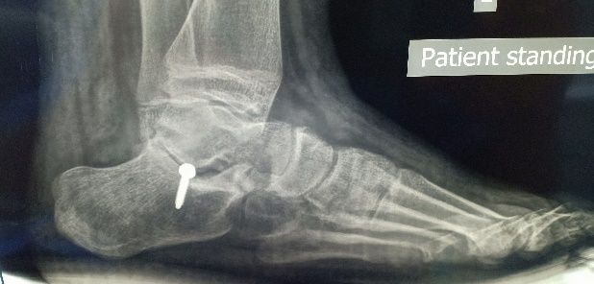
D text here
C here
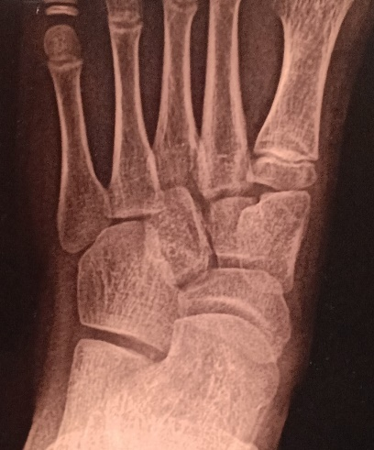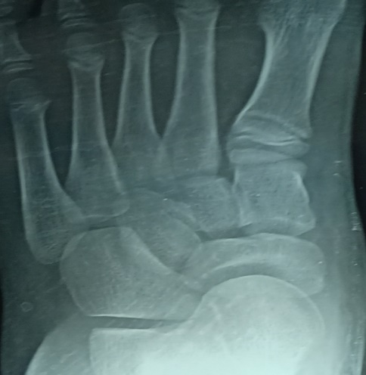
F
E

Figure 4: self-locking arthroereisis implant.
A: preoperative lateral standing X-ray ankle and foot, B: preoperative standing X-ray A-P view foot showing talar head uncoverage, C: postoperative standing A-P X-ray view foot showing corrected talar coverage, D: postoperative standing lateral X-ray ankle and foot, E: postoperative lateral X-ray view ankle and foot, F: postoperative standing A-P X-ray foot.
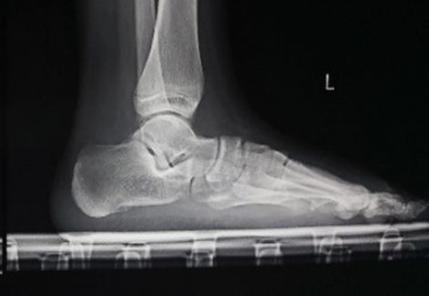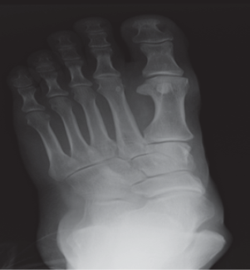
B
A
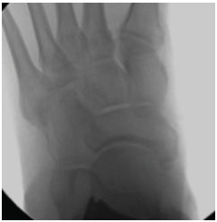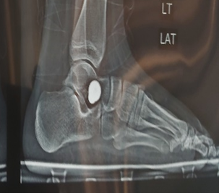
D
C
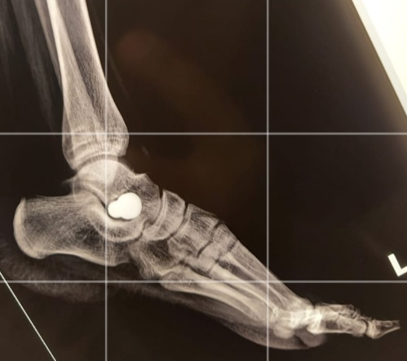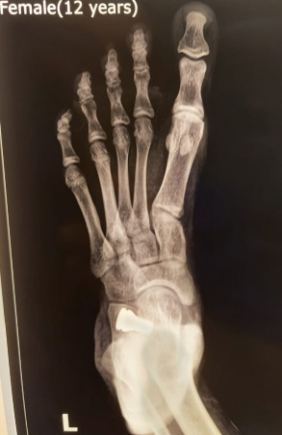
F
E

Figure 5: self-locking extruded implant.
A: antero-posterior standing X-ray ankle view with self-locking implant and B: antero-posterior standing X-ray ankle view with extruded self-locking implant.

